**The Geodesic Dome Design**

Kelly Guaman

ENGL 210

12/11/19

Abstract

The purpose of this experiment is understand the concept of why a unique shape has the ability to withstand different structural forces. Domes has been a creative structure frequently used for designing purposes. Typically, the struts of a geodesic dome are joined together in triangles, with the points of the triangles being approximately on the sphere's surface. The edges of the triangles form great circle-like shapes, or geodesics, over the surface of the dome. The struts form a rigid network that transmits and divides stress forces throughout the structure. As a civil engineering undergraduate, this concept is important to understand how different shapes are built to construct a lot of tourists structures seen today.

Introduction

Geodesic domes are approximately sphere-like structures made up of interconnected triangles. A famous geodesic dome is Spaceship Earth at EPCOT in Walt Disney World, Florida, but geodesic domes are also commonly found as climbing domes at playgrounds. Richard Buckminster Fuller, an American inventor, architect, engineer, and designer, built the geodesic dome in the 1940s and made it popular. The geodesic dome's design gives it some very interesting properties. Geodesic domes enclose more volume per unit of mass of the dome than any other structure made from straight pieces. They are also the only known structure built that increases in strength as the size of the building is increased. As you can see with the geodesic dome, R. Buckminster Fuller was interested in ideas that maximized efficiency in design by building more with less mass. In this science project, I will build a geodesic dome by taping together tubes made from rolled-up newspaper and then investigate the dome's strength-to-weight ratio.

Question

How much mass do you think your dome will be able to support?

Materials

* Sheets of newspaper (44)
* Measuring tape, metric
* Masking tape or painter's tape (1 roll)
* Scissors
* Markers (2 different colors)
* Kitchen or bathroom scale.
* A large tray that will fit the geodesic dome on it. This is for weighing the dome on the scale. The dome will have a diameter of about 58 cm. Alternatively, you could use a small cardboard box and weigh the dome upside down with the top in the box, placed on the scale.
* Many magazines
* Lab notebook

Objective

I will construct a dome using struts made from rolled-up newspaper and determine the strength-to-weight ratio of the resulting dome. Then, I will test out the dome by stacking magazines on top.

Procedure

1. Stack two sheets of newspaper together. Start from the top of edge with a larger length and roll the sheets as tightly as you can to form a tube. Once you reach he bottom tape the tube to keep it from rolling.

Note: Newspaper size can vary but the minimum length needed is 54 cm.

1. Repeat step 1 until you have 22 tubes.
2. Now cut the tubes to have 35 “longs” and 30 “shorts”. Figure 1 shows how you should end up with. Use scissors to carefully cut the tubes.

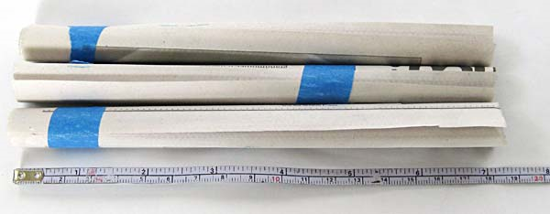

**Figure 1.** Sample of how the tubes should look like.

1. Longs: Use 12 of the 54 cm tubes and cut then in three pieces of 18sm each. Add extra tape to the tubes where needed to keep them rolled up tightly.
2. Shorts: Cut 10 of the 54 cm tubes into three smaller tubes each should be 16 cm long as shown in figure 2. Add tape if needed. You should end up with 30 tubes of 16cm long.

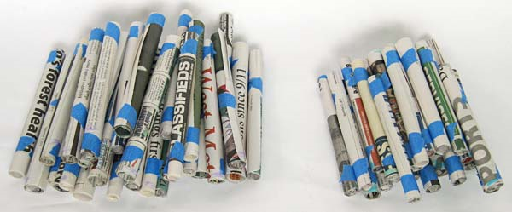

**Figure 2.** Short and long tubes.

1. Tape 10 long tubes together to make the dome base look like figure 3.

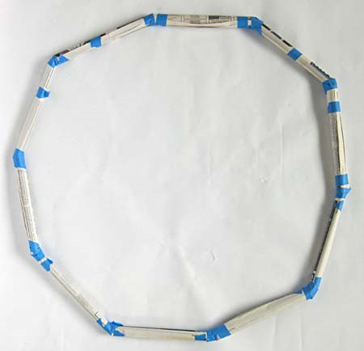

**Figure 3.** Tape together 10 long tubes to make a base like this one.

1. Tape a long and short to each joint and arrange them a way that two longs are next to each other, followed by two shorts tubes, forming a series of triangles. Continue the same pattern all around the base.

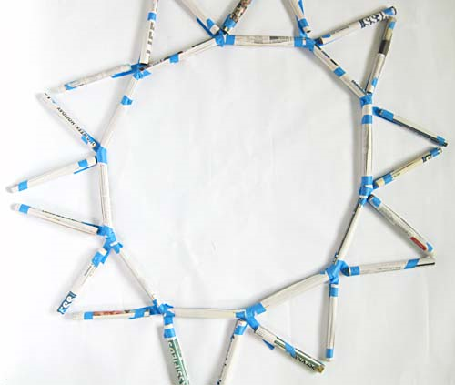

**Figure 4.** Tape a long and a short tube to each joint, placing two longs next to each other, then two shorts, etc.

1. Tape the tops of two adjacent shorts together to make a triangle. Tape the next two longs together, and so on, all the way around
2. Connect the tops of these new triangles with a row of shorts. The dome will start curving inward. As you continue to add to the dome, you may want to add additional tape to reinforce the joints.

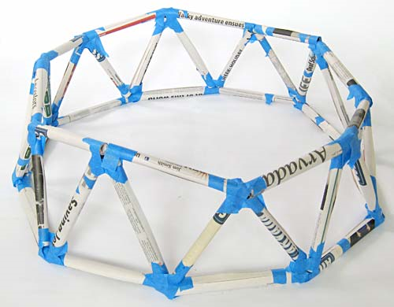

**Figure 5.** Connect the tops of the triangles with long tubes (10 total).

1. At each joint where four shorts come together, tape another short sticking straight up. Connect this short to the joints on either side with longs, forming new triangles.

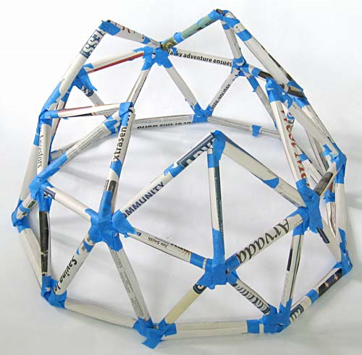

**Figure 6.** Where four short tubes come together, tape on another short tube, pointing up, and then stabilize it with a long tube taped to a joint on either side of it.

1. Connect the tops of these new triangles with a row of longs.
2. Finally, add the last five shorts so that they meet at a single point in the center of the dome. The geodesic dome is now complete. Add additional tape to joints where more support is needed. Figure 7, shows my result.

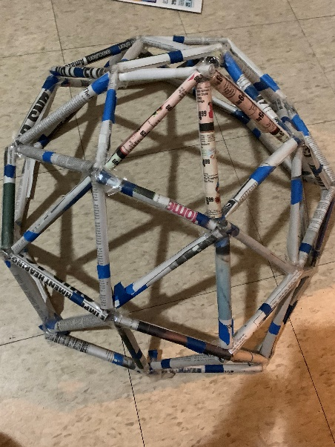

**Figure 7**. My result after finishing taping the dome.

1. Weigh your geodesic dome on the scale. Record its mass (in grams) in the lab notebook.
2. To weigh the dome, place a large tray on the scale, zero out the scale, and then place the dome on the tray.
3. Alternatively, you could place a small, open cardboard box on the scale, zero out the scale, and then place the dome upside down with its top in the box.
4. Test how strong your dome is by seeing how many magazines you can load on top. Add magazines, one at a time, on the top of the dome.

Results

The dome weighed approximately 34 grams. I started the trail with 500 gms and added 50 gms for the next trial. The maximum mass the dome was able to hold is 696 gms. My recordings can be seen in the table below.

|  |  |  |  |  |
| --- | --- | --- | --- | --- |
| Trial 1 | Trial 2 | Trial 3 | Trial 4 | Trial 5 |
| 500 gms | 550 gms | 600 gms | 650 gms | 696 gms |

Analysis

The dome was able to hold about 20 times its mass. This proves that even a domes unique structure is strong enough to hold a mass greater than its own. We can see that light weight material at a low cost can be used to do the same job as material with a higher price. This important work is combined with a desire to make structures that are as beautiful as they are functional and cost-effective.

Reference list

Science Buddies Staff. "Dome Sweet Dome." Science Buddies, 28 July 2017, https://www.sciencebuddies.org/science-fair-projects/project-ideas/CE_p008/civil-engineering/build-a-dome. Accessed 12 Dec. 2019.